


Thriving in Fast Changing Societies: Creating Future Services, Supporting Inclusion
EPR Annual Conference 2018 & 25th Anniversary

20-21 September 2018
Domstad, Koningsbergerstraat 9, 3531 Aj Utrecht, The Netherlands

Building capacity for excellence in service provision for people with disabilities
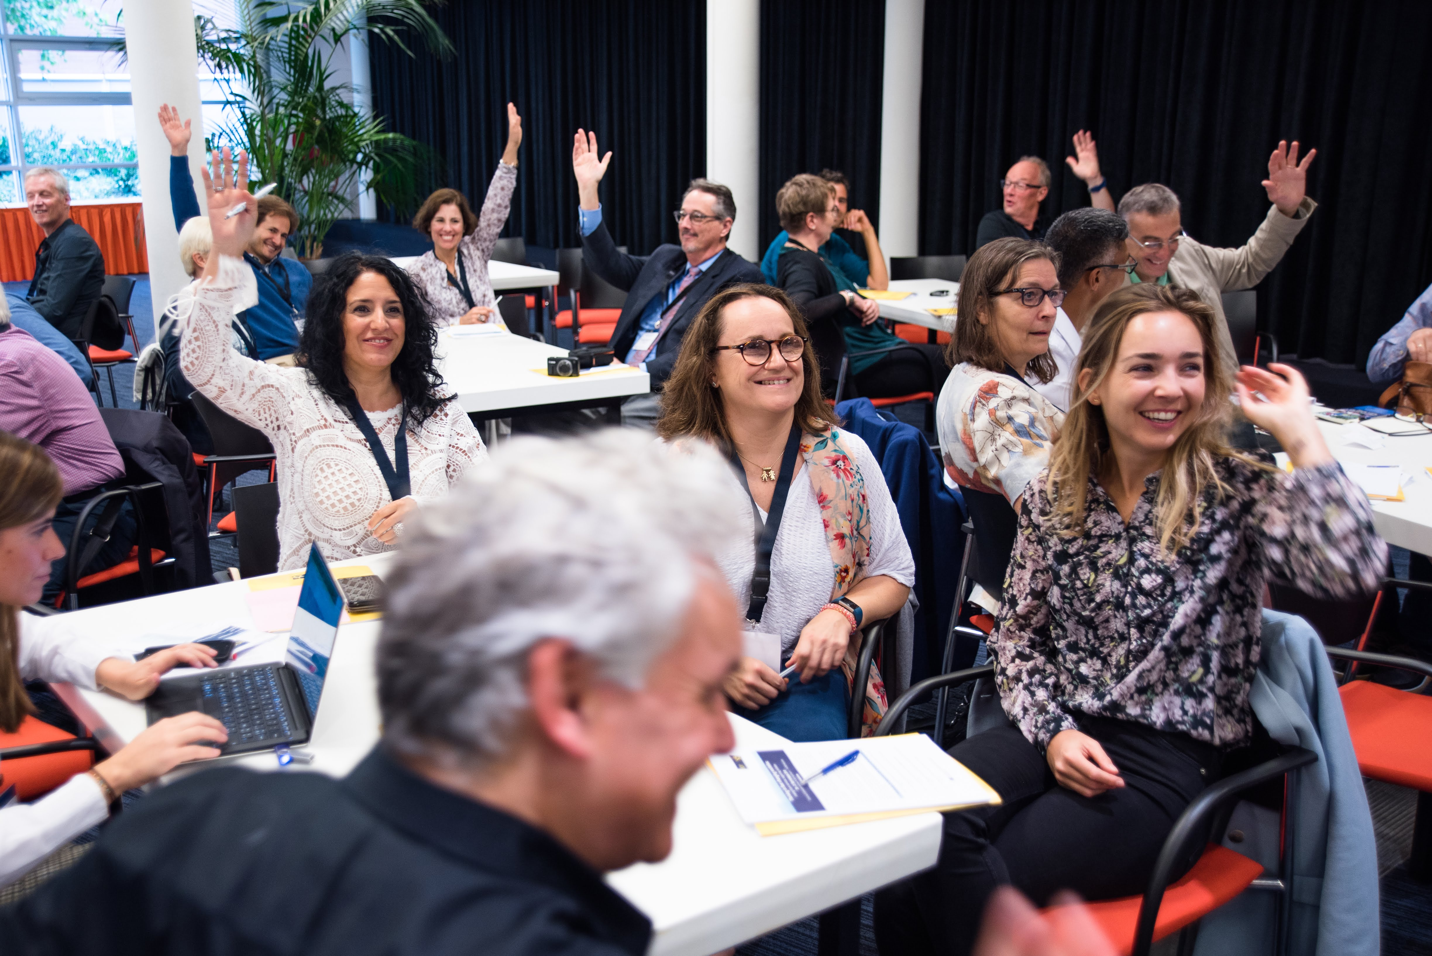
This year’s edition of the EPR Annual Conference, which also marked the 25th anniversary of the network, gathered more than 100 participants, including EPR members and other stakeholders to imagine and create tomorrow’s services together.

Day One of the 2018 Annual Conference began following a few words of welcome and an interactive ice-breaker to warm up the participants. The conference facilitator, Peter Woodward, welcomed the first keynote speaker, Zsolt Bugarszki, Estonian social worker and expert of social policy from Tallinn University. He opened the two-day conference introducing the audience to entrepreneurship in vocational rehabilitation, highlighting that creativity and entrepreneurship are highly interconnected. As he stated, despite the need for social entrepreneurship, various challenges in the long-term care sector remain:
- Solutions remain service-centred;
- Some care systems remain rigid and bureaucratic;
- Overregulation lessens space for creative innovations; and,
- Many parts of the sector still operate with a punitive attitude, especially in post-Soviet countries.
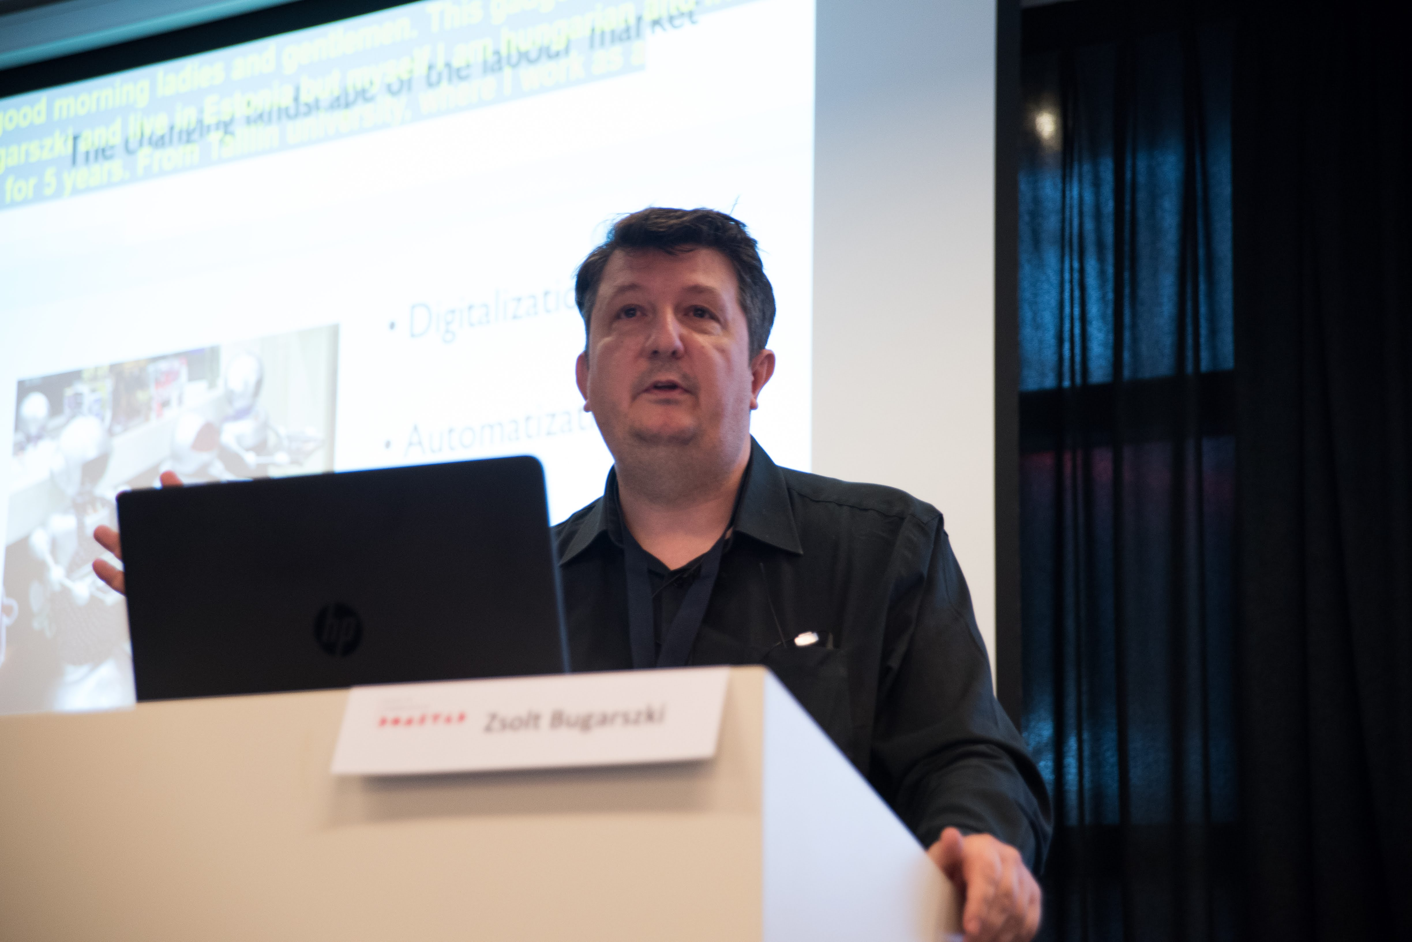
Nonetheless, from small ‘gigs’ in Budapest to hackathons in Estonia, creative entrepreneurship remains an important business strategy that must be welcomed in our changing landscape of the labour market.

Guus van Beek, EQUASS Key Expert, then took the stage to present the new EQUASS system, which systematically ensures future-ready services. It is crucial to avoid setting criteria and indicators that merely appear good on paper but do not impact the quality of services in reality. The new EQUASS system does just that:
- Complies with European Quality Framework for Social Services;
- Achieves tangible service and business outcomes;
- Improves ways of working for better outcomes;
- Explores new ways of working through research and innovation; and,
- Promotes benchmarking in order to further learn and develop.

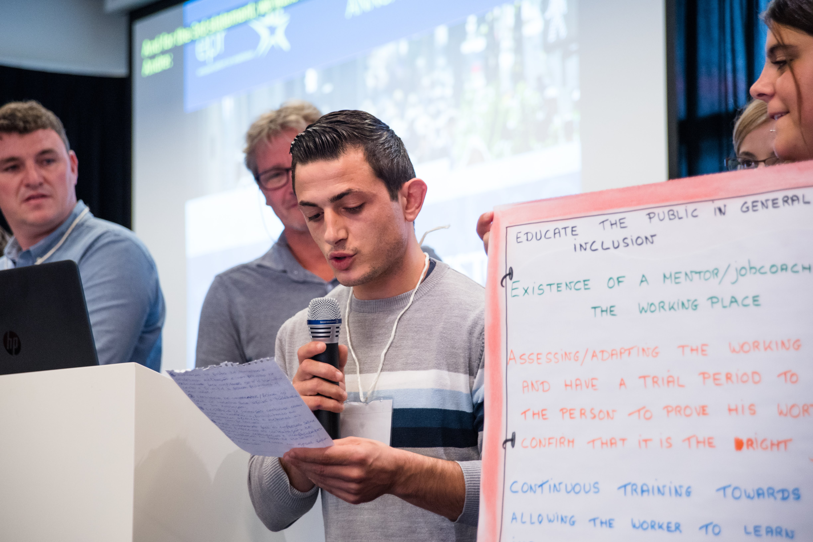
Next, participants from the KA2 Erasmus+ project let by EPR in 2018, “The Future You(th) Want”, presented their Manifesto. Speaking as experts by experience, these participants from different EU countries were young people with and without disabilities who outlined the future that ‘you(th)’ want. A networking coffee break and group discussion then took place on how services can meet needs in fast-changing societies.
After the group discussions, the main ideas where brought to the entire audience to then move towards a presentation of the main key policy tools in the EU social sector related to services for people with disabilities by Laura Jones (EPR Secretary General) and Alicia Gomez Campos (EPR Policy, Communications and Projects Officer).

The presentation moved then to the policy panel with the following speakers: Gunta Anca (member of the European Economic Social Committee), Alfonso Lara Montero (Chief Executive of the European Social Network), Liz Gosme (Director of COFACE Families Europe), and Sabina Lobato Lobato (EPR Vice-President and Director of training, employment, projects and agreements at ONCE Foundation).
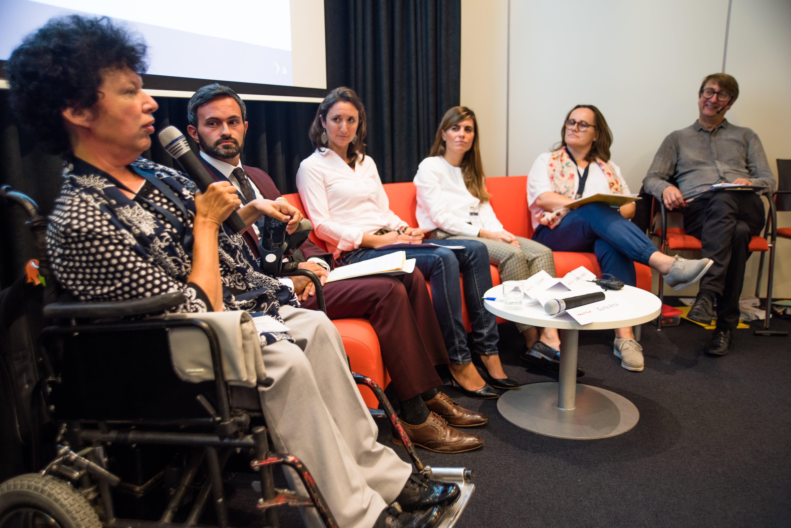
The panel questioned what the right policy mix is for the future and whether we can develop a recipe for quality services and quality of life. The panellists referenced various tools that promoted quality services and quality of life, including the UN Sustainable Development Goals (SDGs), the adequate use of the different EU funds, the European Pillar of Social Rights and the EU Employment Equality Directive 2000. These tools are rooted in principles of non-discrimination, social models of disability, and rights to reasonable accommodation.

Looking forward, the panellists outlined several EU funding programmes post-2020 as key to the right implementation of those policies. These funding programmes are prime areas to promote quality services and quality of life.

The panel was followed by an interview with Zsolt Bugarszki, summarizing the lessons learnt and ideas for the future.
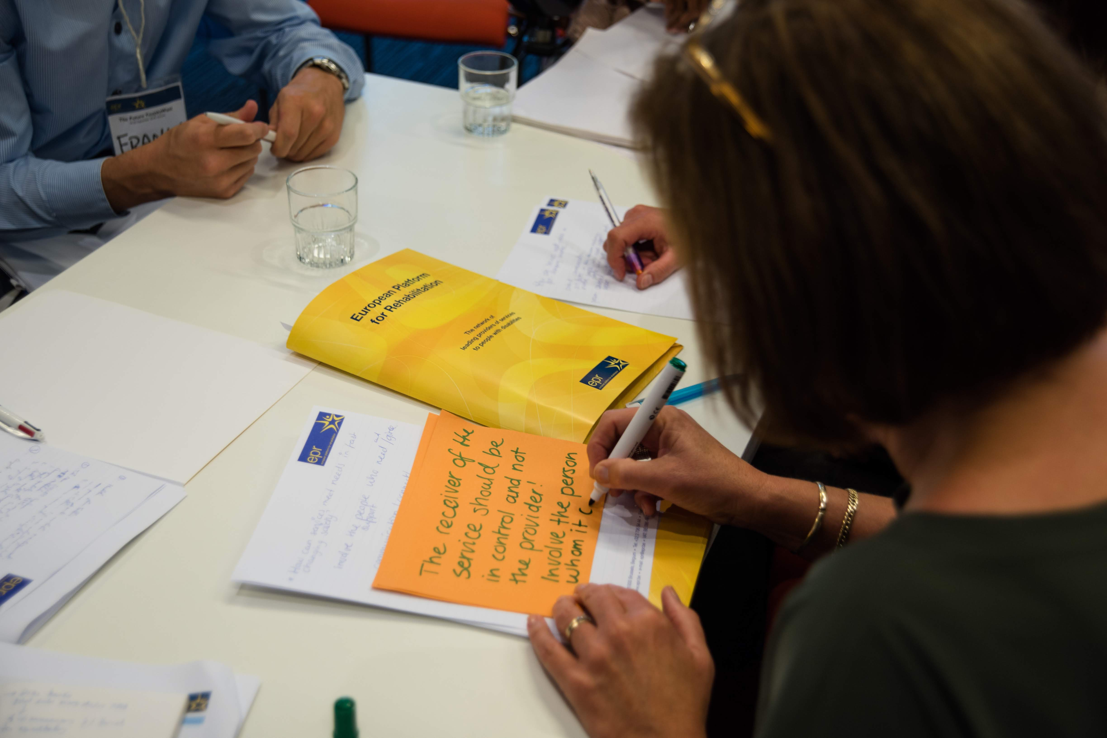
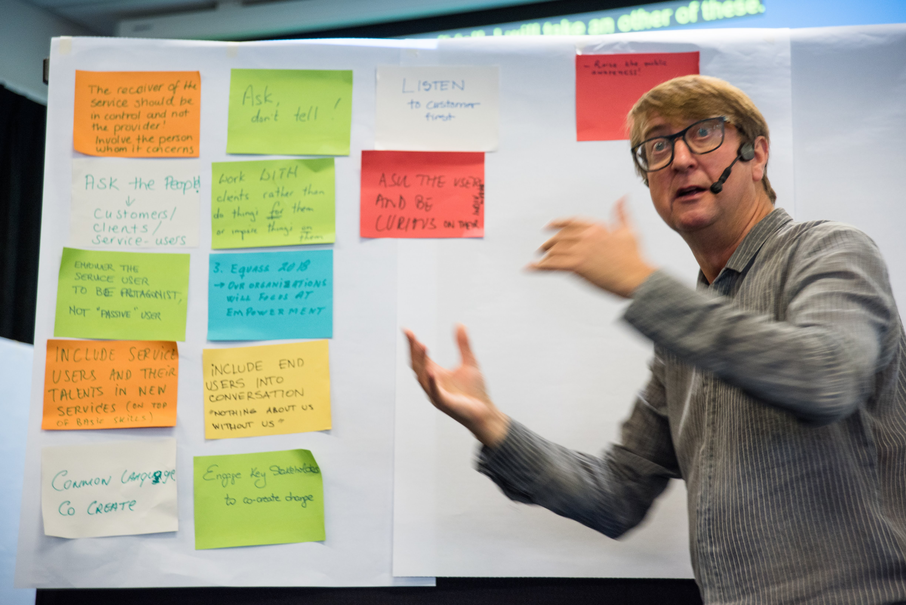

After the networking lunch, the afternoon engaged participants in a series of training workshops.

Six workshops took place simultaneously and participants were able to attend their workshop of choice:

Workshop 1: Beyond business: employment of people with disabilities in the social sector.
This workshop was led by the Talentoscoop project partners: GTB (Belgium), Inserta (Spain), CRPG (Portugal), and Corvinus University (Hungary).

The Talentoscoop project aims at increasing the employment rate of individuals with special support needs in the non-profit social sector. Through interactive sessions facilitated by Peter Woodward, the partners presented the outcome of the project developed so far and engaged participants in sharing ideas and experiences to successfully employ people with disabilities in the social sector.

Workshop 2: Motivational Interviewing: promoting positive change among colleagues and clients.
This workshop was led by Paul Delaney (Director and Principal of COAIM - Change Outcome and Impact Measuring).

This workshop focused on teaching Motivational Interviewing to other professionals to help them increase their skills in promoting positive change, and to improve the effectiveness of communications between work colleagues and clients.

Participants received free access to the online training course 'Motivational Interviewing Foundation Level Training Course' prior to the workshop. This enabled them to have a solid understanding of the theory that underpins Motivational interviewing before attending the workshop in Utrecht.

During the workshop, the participants had the opportunity to observe and practice Motivational Interviewing through role-playing scenarios provided by the presenter. Participants became familiar with the general principles of Motivational Interviewing, were equipped with extra tools to build on their existing client engagement skill, and gained the confidence to use Motivational Interviewing skills in their own work settings.

Workshop 3: Restorative approaches to manage challenging behaviours in educational settings.
This workshop was led by Belinda Hopkins (Director of Transforming Conflict at the National Centre for Restorative Approaches in Youth and Community Settings in the UK).

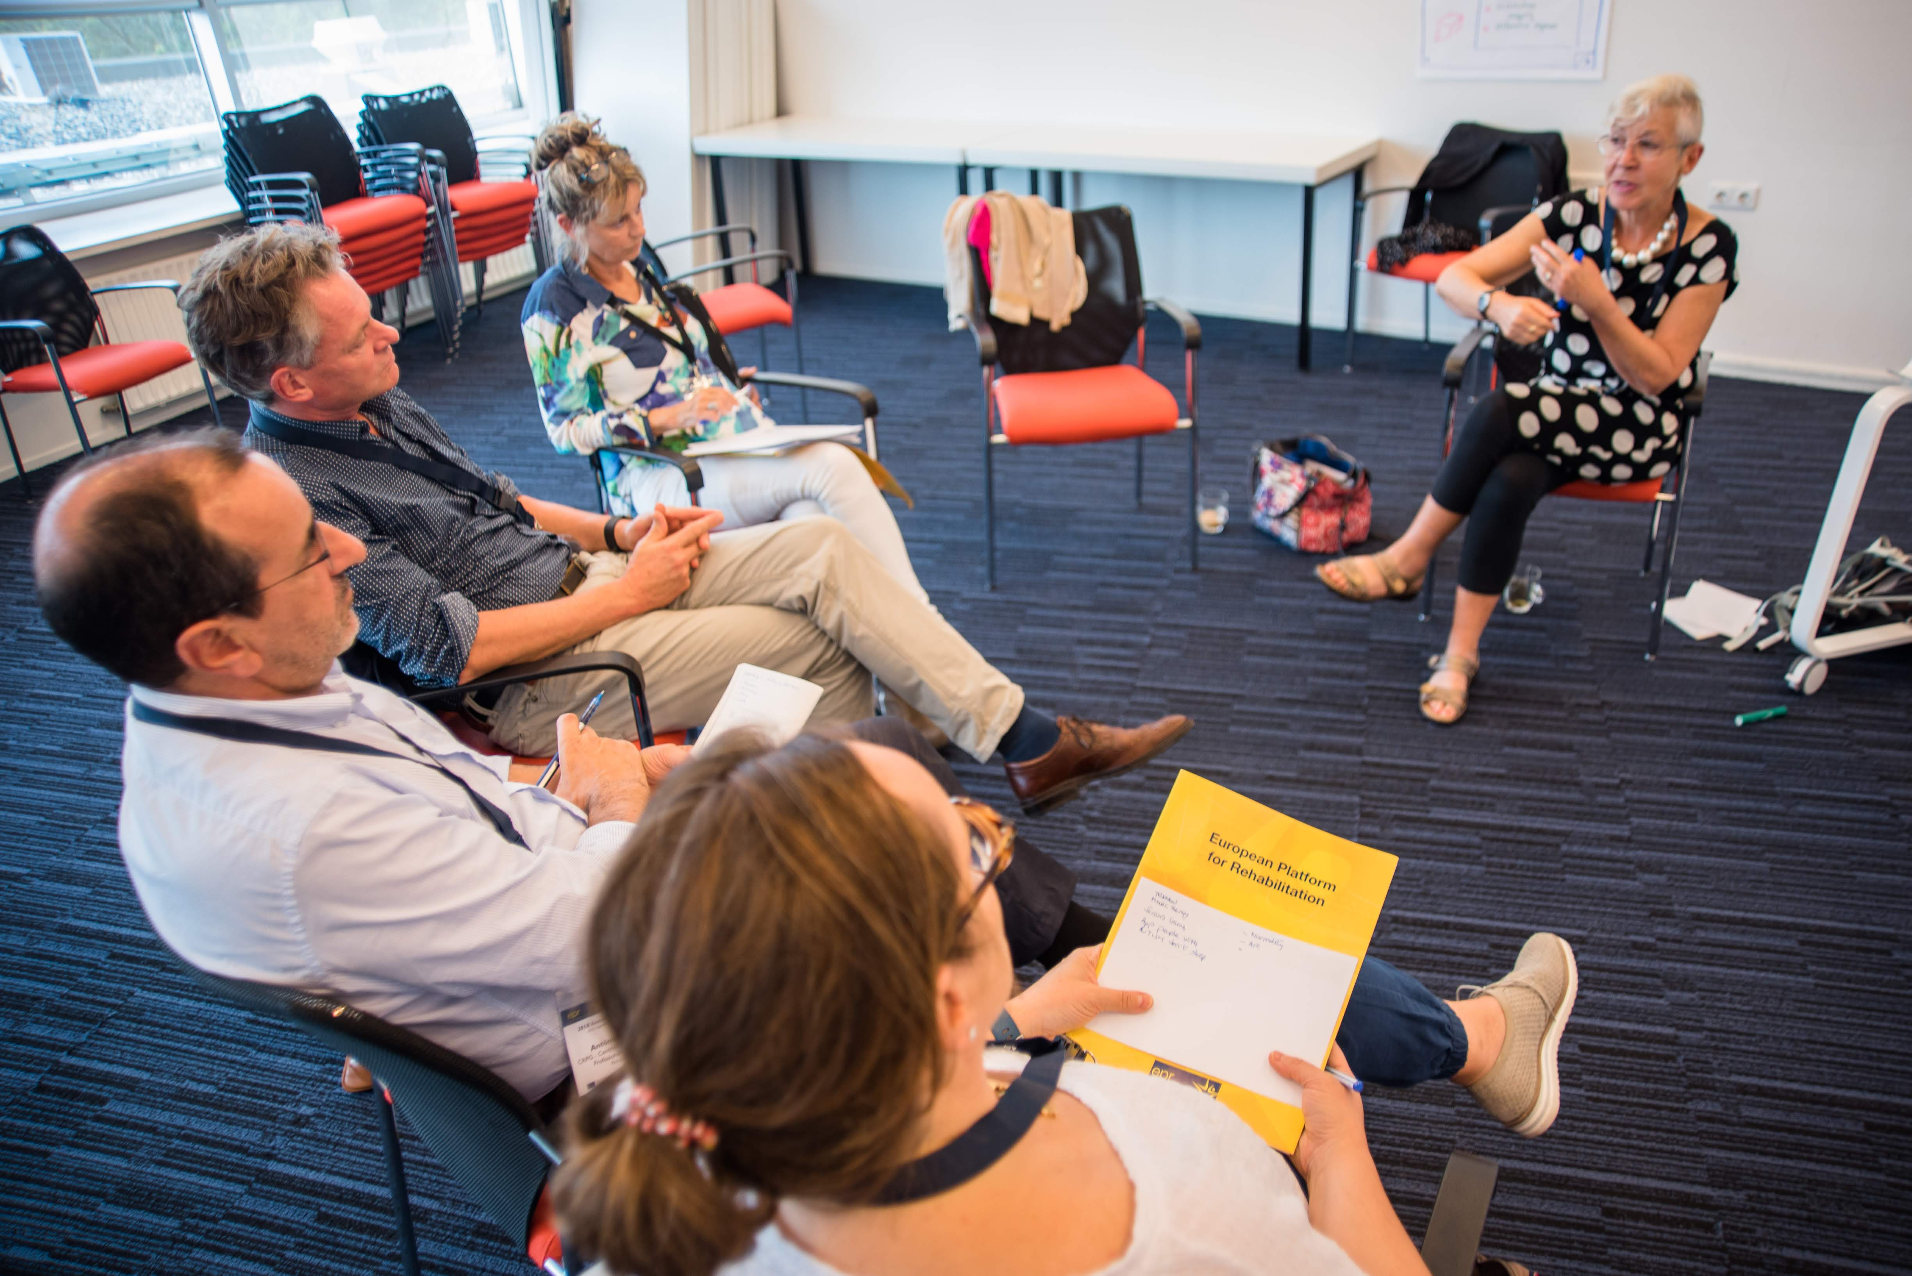
This workshop focused on learning restorative approaches in youth settings across the UK and beyond. Belinda outlined how the ethos, principles and practices of Restorative Approaches can transform communities and institutions. Participants learned how to transform schools into restorative schools by promoting inclusion, empowerment, respect, confidence and accountability, by accounting for future labour market challenges and needs, and by embracing new requirements in vocational training.

Workshop 4: Person-centred support skills for community inclusion.
This workshop was led by Sarah Bickerton (trainer on person centred thinking, planning and practice in the UK).

This workshop centred on how service providers can support individuals with disabilities to attain a good quality of life through the application of person-centred planning and person-centred practices. This workshop discussed the importance of rights, choice, independence, co-production and inclusion in providing services to people with disabilities. This workshop explored what it means to be a citizen and how we can empower people with disabilities to overcome the barriers they face to citizenship and social inclusion. Participants looked at person-centred planning tools to facilitate and support this process. The workshop took an interactive approach allowing participants to understand how to use practical tools with the people they support to empower and increase their status as socially included citizens.

Workshop 5: Working successfully in networks for integrated care.
This workshop was led by Dr Roger Green (Director of Tricordant of the UK).

This workshop taught participants how to successfully work in complex and networked organizations for integrated care. This workshop explored the leadership capabilities required for a network of partnerships; highlighted experience from the UK in developing a person-centred system for integrated care and its potential for application in other countries; reflected on the challenges in integrated care and what public authorities need to do to address them, and outlined whether and how funding or service organization need to change.

Workshop 6: Next steps: The Roadmap for implementing the Manifesto.
This workshop was led by participants from the Erasmus+ programme who presented their Manifesto during Day One of the Annual Conference. These participants were young people with disabilities who were speaking as experts by experience. This workshop outlined how to make the Manifesto that outlines the future you(th) want a reality.


As the workshops came to a close, the evening Reception and 25th Anniversary Gala Dinner took place. The Gala Dinner gathered EPR alumni and friends to celebrate the achievements of EPR over the last 25 years, share good memories and inspire the future.

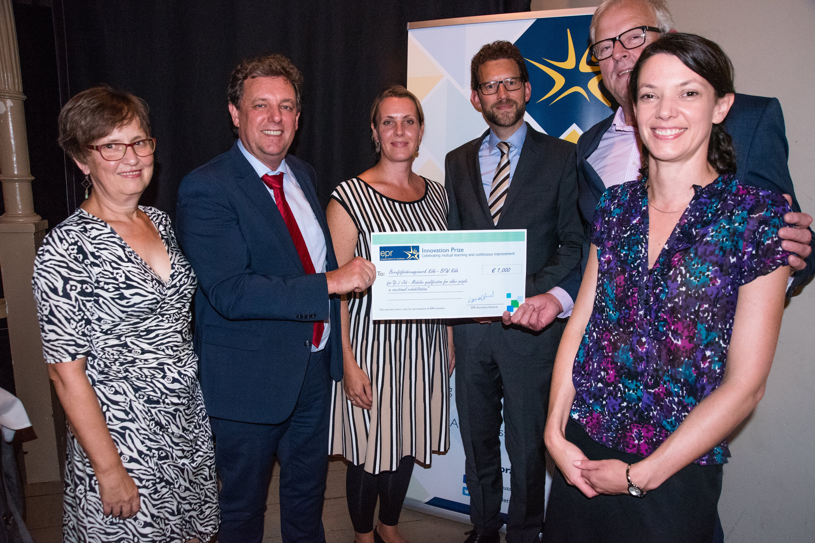
The Gala Dinner also awarded the 2018 EPR Innovation Prize. This year, BFW Koln of Germany was the winner for their go2job innovation that promotes modular qualification for elderly people in vocational rehabilitation. The other two finalists included RehabGroup’s CARA Outreach support services, along with ONCE Foundation’s Supported entrepreneurship program (EmCa). The evening ended with a three-course meal and a live band.

Day Two of the 2018 Annual Conference began with a panel discussion on shifting up the gear on employment of people with disabilities.

The panellists included were: Luc Hénau (President of the European Union of Supported Employment in Belgium), Kathleen West-Evans (Director of Business Relations for the Council of State Administrators of Vocational Rehabilitation in the United States), and Brendon Roach (Senior Disability Consultant for the Business Disability Forum in the United Kingdom).

The panel was followed by mutual learning sessions that displayed inspiring practices from EPR members and beyond. The mutual learning sessions were organized by six focal themes:

- Co-production: Chaired by Ronald Schollaart, this session looked at two projects that centred on co-production: the BE RIGHT project (Spain) and the INCORPORA project (Portugal).
- Employment: Chaired by Laura Jones, this session discussed three initiatives that focused on employment: the Vocational Rehabilitation Business Relations Training model (USA), the go2job initiative (Germany), and the Supported Entrepreneurship project (Spain).
- Independent living: Chaired by Alicia Gomez Campos, this session discussed three initiatives related to independent living: the Helpific web-based support environment (Estonia), the CARA outreach programme (Ireland), and the Frailsafe project (Belgium).
- Mental health: Chaired by Mirko Miceli, this session highlighted three approaches focusing on mental health: the From ICF to a Psychosocial Approach to Personalized Wellbeing (Greece), the Listening to the Silenced Body program (Portugal), and the Recovery Supported Care approach (The Netherlands).
- Quality in social services: Chaired by Sarah Vansimpsen, this session focused on the new EQUASS system, addressing quality concerns and outcome measurement. This session brought together Alex Rebelo (Portugal) and Guus van Beek (The Netherlands) to discuss ensuring quality and performance assessment.
- Speed-Dating topics: Chaired by Peter Woodward, this session allowed participants to discuss a number of different themes: maintaining jobs for people with disabilities (Portugal), neurorehabilitation and non-invasive brain stimulation (Italy), moral dilemmas in case work (The Netherlands), innovation and meaningful growth (Sweden), supported employment (France), the Job Fair programme (Estonia), and supporting personal mental health recovery through the Recovery Context Inventory (Ireland).

The ideas and initiatives highlighted in the mutual learning sessions were then outlined for all participants.

David Casinos, paralympic trainer and motivational speaker from Spain, then enlightened the conference attendees with a motivation speech: “The sun rises every morning, but if it doesn’t, I’ll make sure it does.”

Finally, Laura Jones (EPR Secretary General), Frits Wichers (EPR President from Heliomare in the Netherlands), and Sabina Lobato Lobato (EPR Vice-President from Fundación ONCE in Spain) closed the final day of the EPR 2018 Annual Conference by summarizing focal discussion points that arose during the two days and providing reflections for the future.

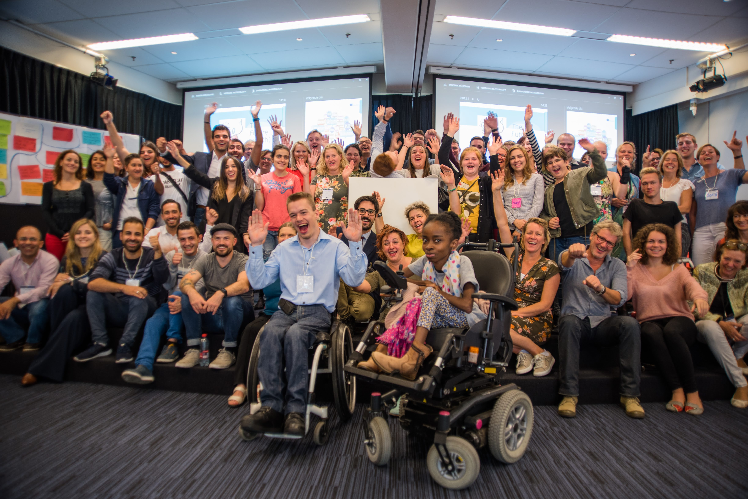
More information can be found on the EPR website, including the official photo album.

