Study on Support for Independent Living for People with Disabilities
Easy-to-Read Summary



What is this study about?
This document is about independent living.
It tries to help people understand better
what independent living is
and how to make it happen.
What is Independent Living?

Independent living is a right.
Independent living means:
- You can choose where to live.
- You can choose who to live with.

- You have support when you need it.
- You can make decisions about your life.
- You have the same chances as other people.
It does not mean doing everything alone.

It means getting help to live the way you want.
Everyone needs some help sometimes.
People with disabilities have the right
to choose what help they want.

What do persons with disabilities need
to live independently?
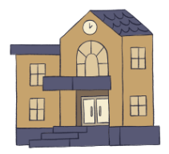
Housing
In institutions many people live together.
They do not have choices.
They do not decide what to do each day.
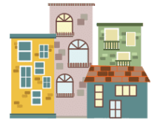
People need their own safe accessible homes.
Homes should be in the community,
not separated from where most people live.
People should be able to pay for their own homes.

Support
People need support in their own homes,
in the community.
People can get help from personal assistants.
Personal assistants help people with their daily activities.

Money
People need enough money to live, for example
- for food
- housing
- and support.
Accessible services
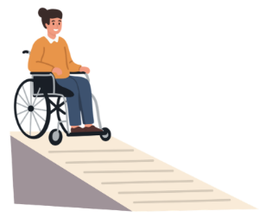
For example,
you should easily be able to
- Use buses.
- Go to shops.
- Get health care.
- Go to a regular school.

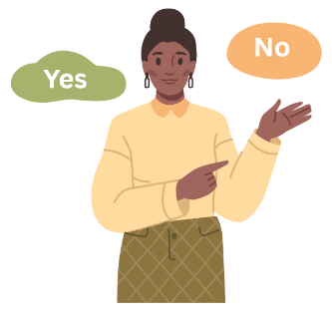
Decisions
You should have support to help make decisions
if you need it.
You have the right to say no.
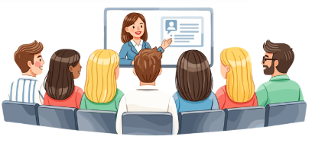
Training and education
You should have chances to learn new skills
and to find work that you like.
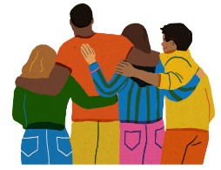
Friends and community
You should be able to be part of their community,
have friends
and do activities you enjoy.
What are governments doing?
Many European countries are changing their services.
Spain

Spain made a plan to change from institutions
to community support.
The plan includes:
- Training for people working in support services
- Money for new services
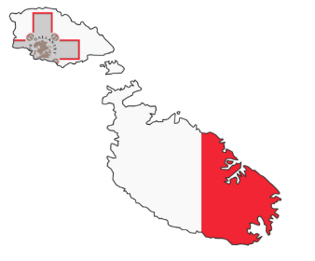
- Homes in the community
Malta
Malta is making big changes to disability support.
They are introducing personal budgets.

Personal budgets let you choose how you spend money
for your support.
Sweden
Sweden has strong personal assistance.
People choose who helps them.
They say when and where they need help.
Examples of support services

The document also gives examples
of how organisations give people support
to live independently
in different countries.
The examples can give ideas to other organisations, about how they can support independent living.
Why is Independent Living not Happening?

Money
There is often not enough money from government
for services in the community
or personal assistants.
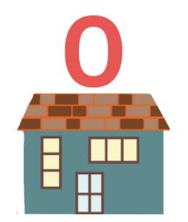
Money is still spent on institutions.
Housing
There are not enough accessible,
affordable homes.
Services
Some places do not have services in the community.
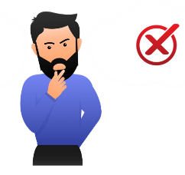
Attitudes
Some people think people with disabilities
cannot live independently.
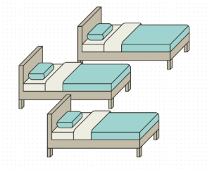
This is not true.
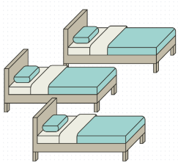
Planning
Services are sometimes organised around
how many people live together,
Not on what people need

Complicated systems
Sometimes health services and social services
do not always work together.
This can make it hard to get support.
What needs to change?

Governments need to:
- Make laws that protect the rights
of persons with disabilities
- Give more money to community services
Help health and social services work together


- Stop building new institutions
- Make sure housing is accessible
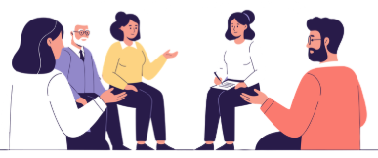
Organisations providing services need to:
- Listen carefully to persons with disabilities.
- Help people make their own decisions.

- Train the people working in the organisation
about rights.
- Work with families and other services.
- Tell the government what persons with disabiities need.

Communities need to:
- Understand that persons with disabilities
can live independently
- Welcome and include persons with disabilities.
- Help create accessible services and buildings.
The EQUASS programme

EQUASS helps organisations
that work with persons with a disability.
It gives them advice
about how to help people live independently.
Organisations can be tested
to see if they follow all the advice.

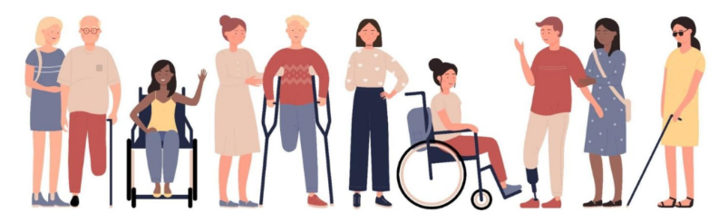
Final message
With the right support,
and everyone working together,
persons with disabilities
can live independently.

Easy-to-read text by Laura Jones.
For more information about Easy-to-read, see Inclusion Europe’s website: https://www.inclusion-europe.eu/easy-to-read/

-----------------
Study Acknowledgements
Author: Laura Jones, Freelance Analyst and Consultant
Research manager and editor: Alicia Gómez Campos, EPR Secretary General and Clara Beser Ramada, EPR Policy Officer.
Contributions: Priska Schukoff, Eva Skergeth-Lopic (Chance B Gruppe), Sara Marcos Ispierto, Pablo Sánchez Pérez (Fundación INTRAS), Aoife Ó Murchú (Rehab Group), Rebecca Leon Gracia, Mónica Aznar, Amador Sánchez Bea (Fundación Rey Ardid), Susana Ortega Bataller, Miguel Franco Pradas, María Cristina Cebolla Vercher (Fundación SASM), Orane Jouanneau, Helena Clark (LADAPT), Ana Juviño Prego (Fundación ONCE), Nektaria Sifaki, Aphrodite Korogiannaki (Theotokos Foundation), Katrina Sevruka (The Social Integration State Agency - SIVA), Lene Odberg Borvik (Fønix AS).
© Copyright European Platform for Rehabilitation (EPR) www.epr.eu

Co-funded by the European Union. Views and opinions expressed are however those of the authors only and do not necessarily reflect those of the European Union or the European Commission. Neither the European Union nor the granting authority can be held responsible for them.

