

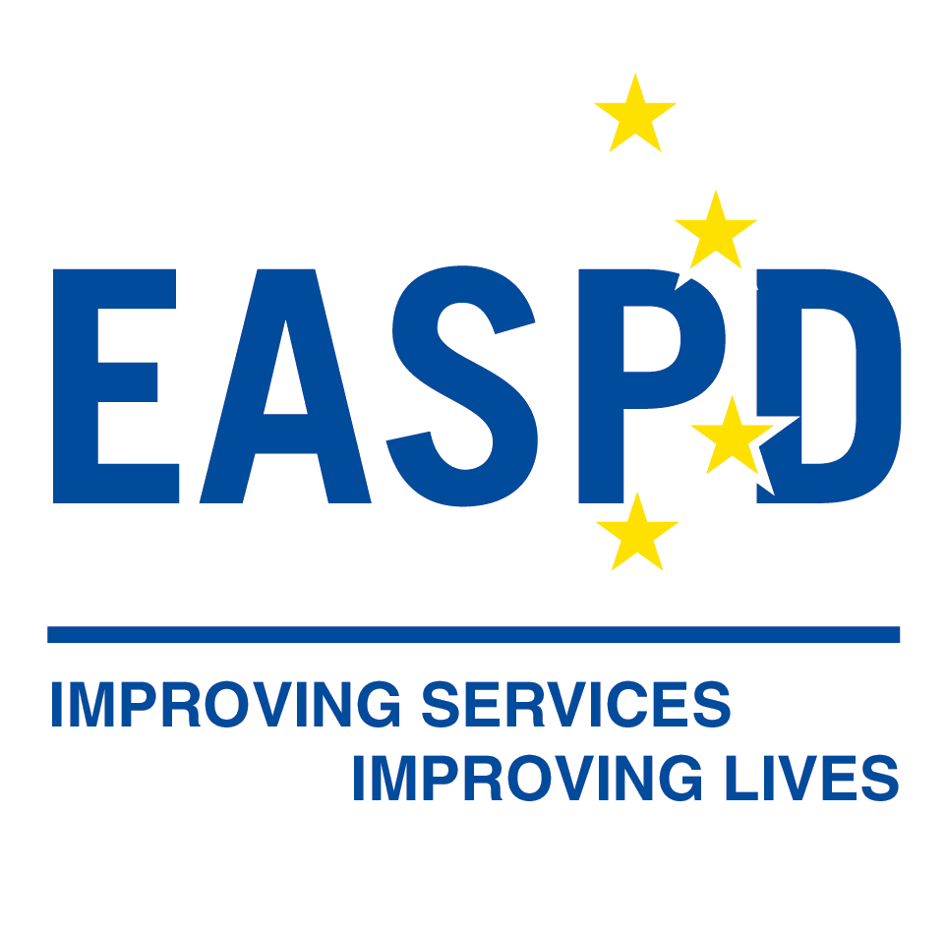

Employment models within the social economy:
Unlocking their potential to include people with disabilities in the labour market
Public Affairs Event

6 December 2018
9:00 – 13.00
Avenue des Arts 8, c/o CCI ‘Salle Delvaux’ 1210 Brussels

Building capacity for excellence in service provision for people with disabilities
After a warm welcome from Sabina Lobato Lobato, EPR Vice President, and Luk Zelderloo, EASPD Secretary General, researchers from the Policy Impact Lab, Elma Paulauskaite and Andrius Tursa, were invited by Alicia Gomez Campos, EPR’s Policy, Communications and Projects Officer to present the state of the research on employment models within the social economy they are developing under the coordination of both organisations EPR and EASPD.
Exploring employment models for persons with disabilities in Belgium, Germany, Lithuania, Norway and Spain, this research looks into how social economy enterprises promote inclusion of people with disabilities in employment. During their presentation, the researchers shared some preliminary findings:
- While there is no single definition of ‘social enterprises’ across the EU, the European Commission has put forth a few common characteristics that set ‘social economy enterprises’ apart from other organisations:
  - Explicit societal objective
  - Reinvestment of profits into the core activities
  - Inclusive ownership and governance

- The study confirmed that the understanding and definitions of ‘social economy enterprises’ varied greatly in the five overviewed Member States depending on national historical, social and economic contexts.
- As a result, all five overviewed countries had very different and unique employment models for persons with disabilities within social economy.

- Germany: there are around 750 workshops for persons with disabilities, offering various services for persons with disabilities, including employment in sheltered environment, vocational training and guidance for persons with intellectual, psychosocial and multiple disabilities. Transition rates from these workshops to the open labour market, however, remain low.
- Lithuania: there are around 190 social enterprises, which are private for-profit companies. According to the law, persons with disabilities must comprise at least 40% of such companies’ workforce. Social enterprises employ mostly persons with moderate and light disabilities. The model is considered as largely ineffective and financially unsustainable by the government and NGO representatives and may be reformed in the near future.
- Norway: there are around 350 work inclusion companies in Norway. One of the schemes implemented by them is work preparation training (AFT), which targets people with ‘reduced work capacity’. The scheme offers a comprehensive training programme, which includes work experience both in sheltered and open labour market environment in addition to vocational training courses and follow-up support. After completing the scheme, around 27% of participants transition to the open labour market, while another 9% continue other training/education courses. The scheme is popular and there is a considerable waiting list to participate in it.
- Spain: there are around 2215 special employment centres (Centros Especiales de Empleo) in Spain, employing 64,400 persons with disabilities. These centres offer persons with disabilities productive and remunerated work and facilitate their transition to the open labour market, depending on the employees’ individual preferences, professional qualifications and various other factors. Most of these organisations are profitable, although public funding/tenders represent the largest share of their revenue.
- The diversity of employment models for persons with disabilities within social economy sector across the EU must be accounted for when measuring their performance and supporting them.

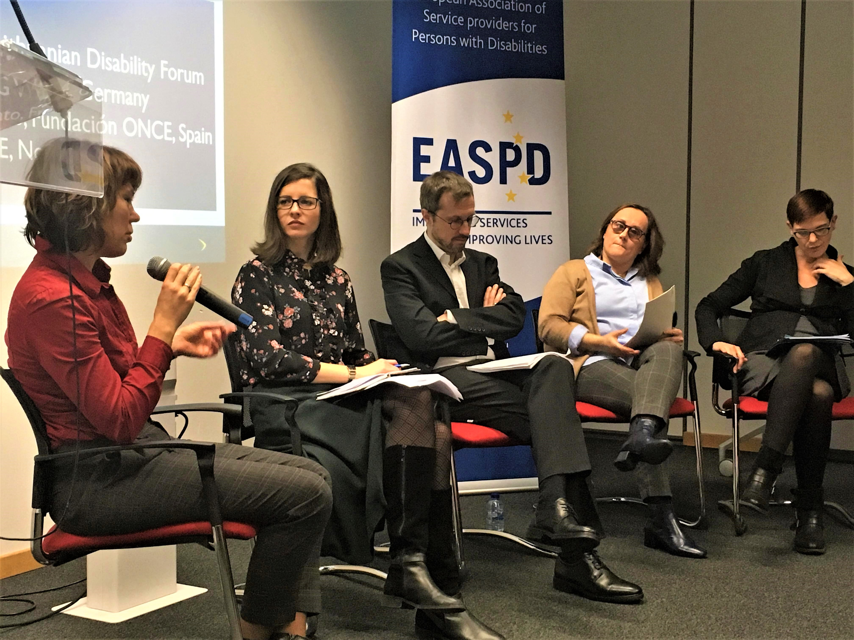
A panel of four experts representing each country was called to the floor by Sabrina Ferraina, EASPD Policy Manager, to discuss the research findings: Katharina Bast, BAG WfbM (Germany), Henrika Varniene, Lithuanian Disability Forum (Lithuania), Jon Qvortrup, AVRE (Norway), and Sabina Lobato Lobato, Fundación ONCE (Spain). Each expert highlighted experiences from the ground, focusing on main trends, challenges and success factors.

Based on the panel discussion, the main conclusions that emerged were:
Different actors, different needs: Social enterprises must account for the needs of all actors. This includes the people with disabilities themselves, but also the needs of the State, the companies, and the employers.
Not just needs, but also preferences: Social enterprises should not only account for the needs of people with disabilities, but also their preferences in employment.
2008 Convention on the Rights of Persons with Disabilities: More work needs to be done to ensure that the Convention and the reality of social enterprises and the open labour market are aligned. Without an inclusive labour market, it is difficult for people with disabilities to carry out their rights under the Convention.
Digitalization: Upcoming digitalization must be accounted for in social enterprises. It must be seen not as a challenge, but as an opportunity for improvement, efficiency and accessibility.
Legislation: Current national legislation surrounding social enterprises is sufficient across Germany, Lithuania, Norway and Spain. In Spain, however, because social enterprises are an older practice, the legislation is outdated and requires updating. Across all four countries, the overarching challenge is around effective implementation of this legislation.

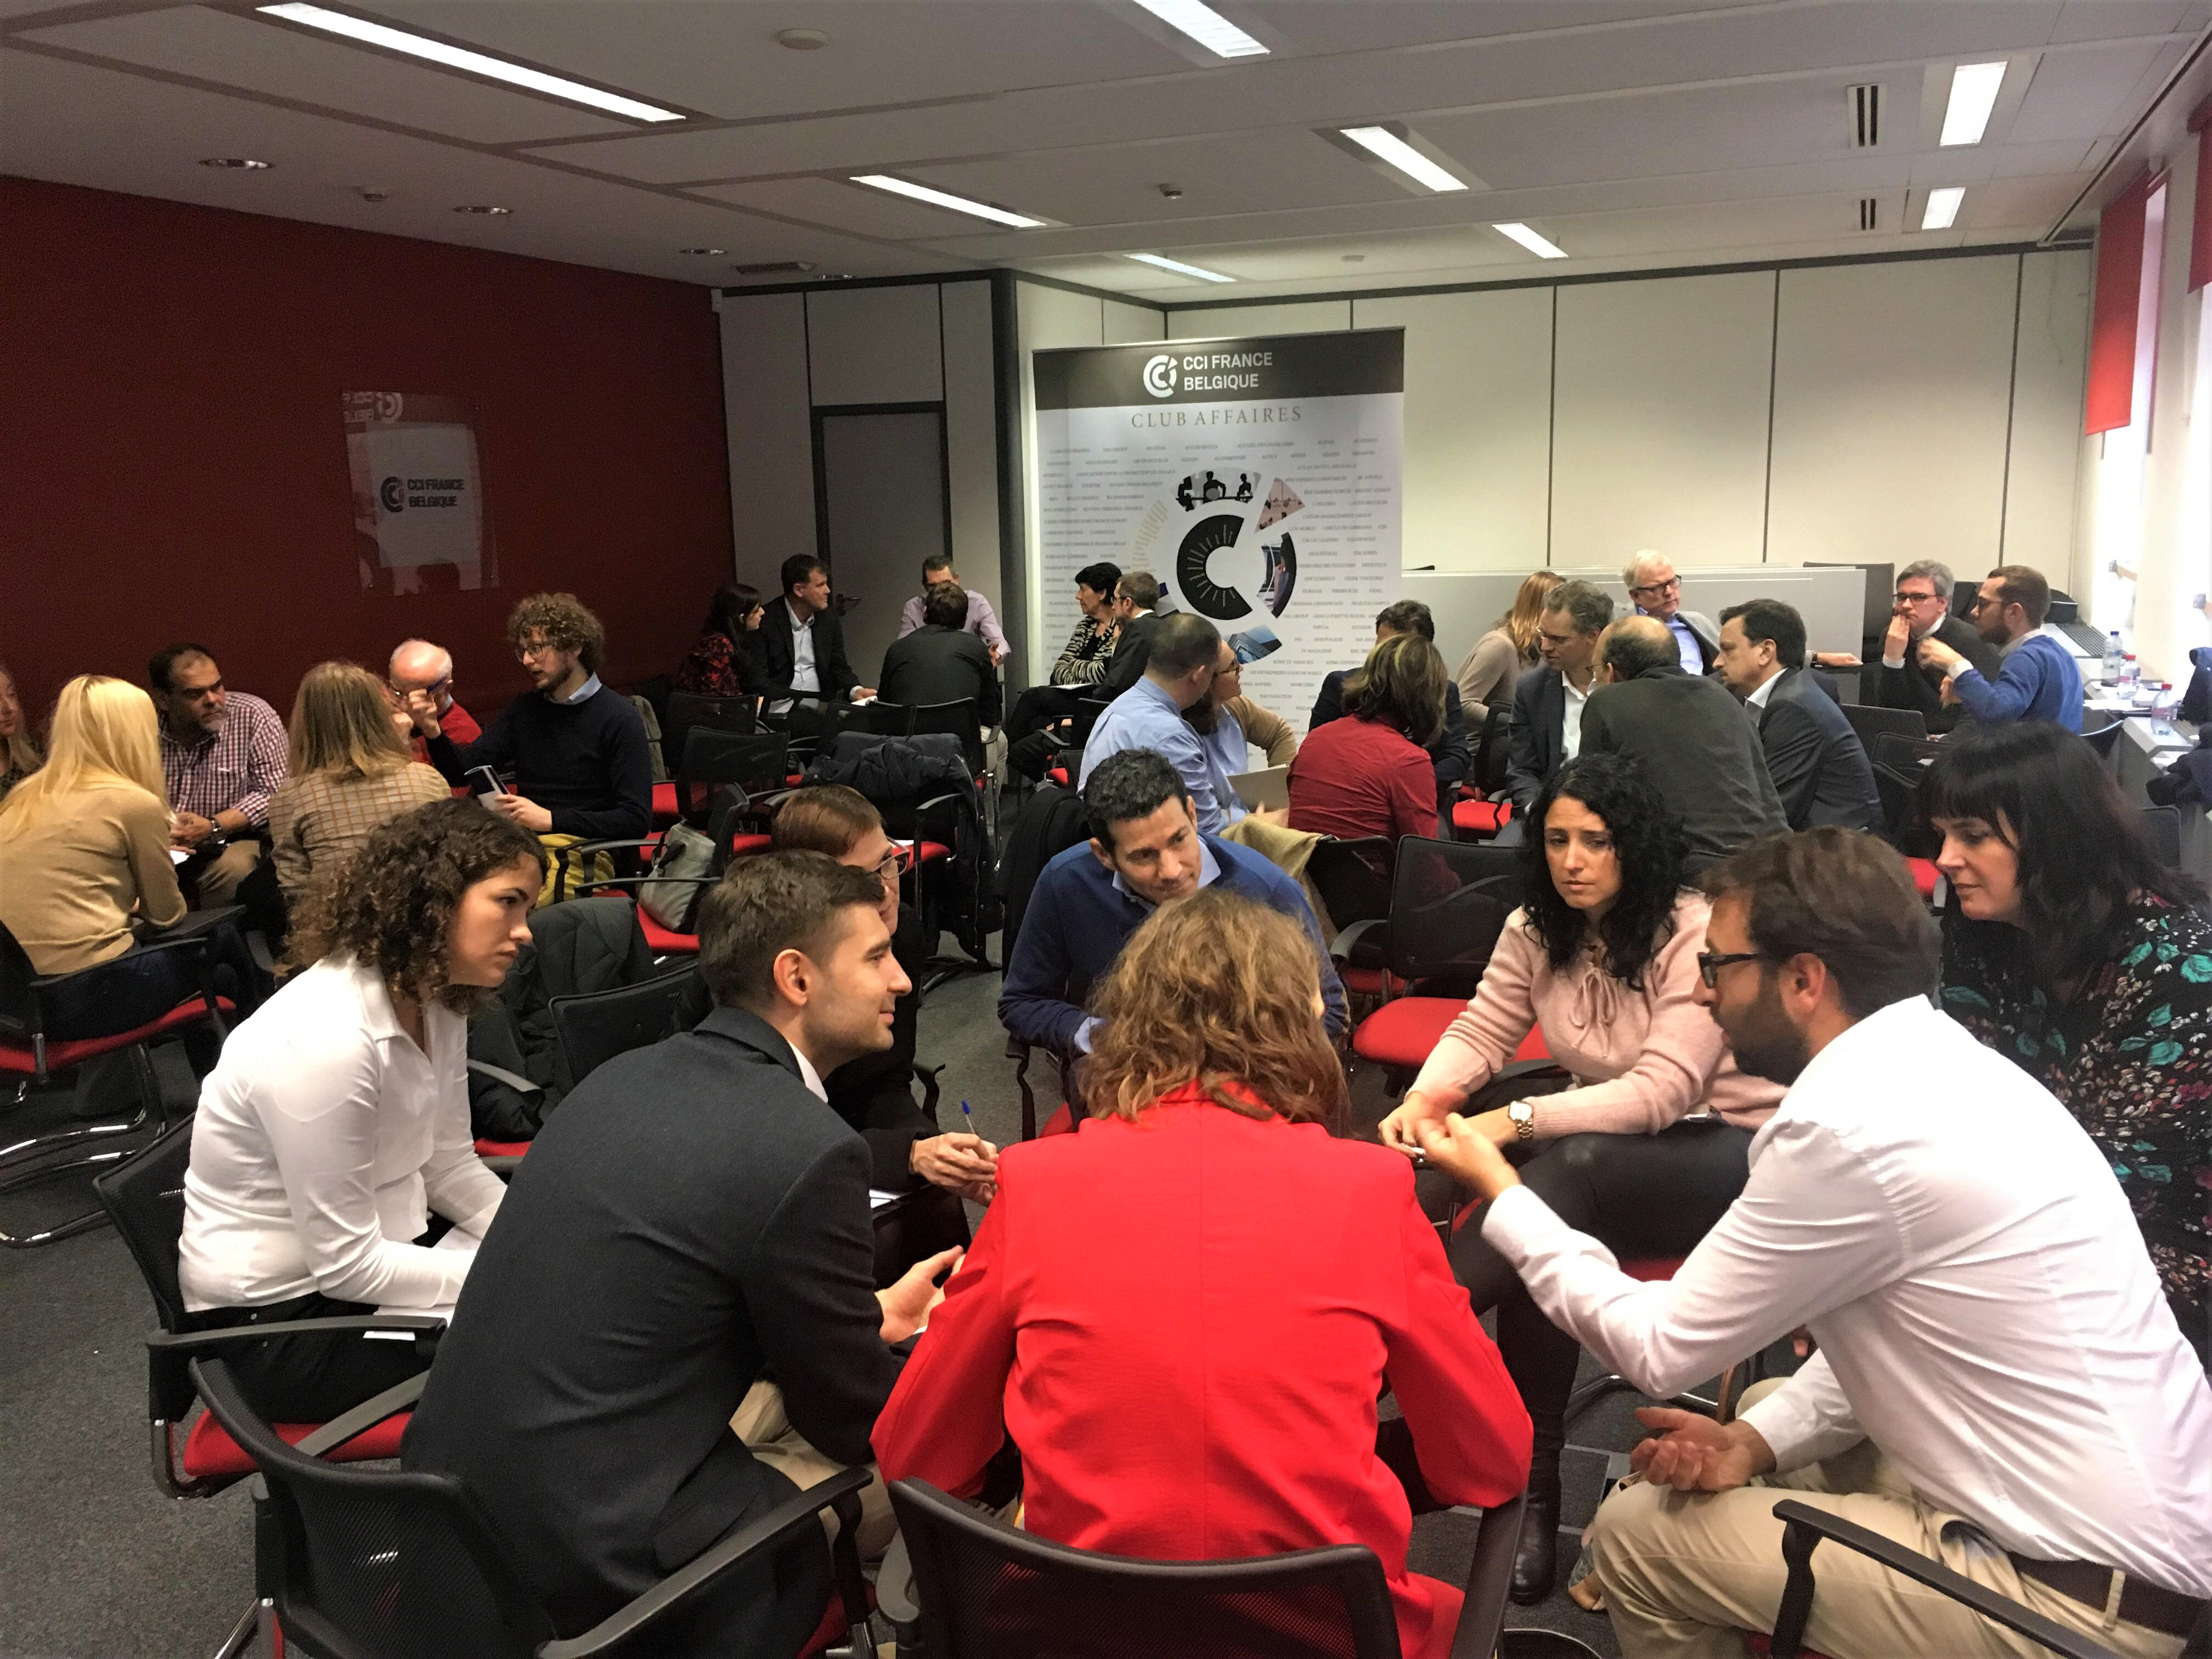
After the coffee break, the audience was divided into various discussion groups. The audience worked in social enterprises or similar organizations and were surprised to hear about similar experiences despite different country contexts. However, rather than commonalities, groups proposed focusing on differences instead because they can speak to innovative, unique approaches that other social enterprises have not yet encountered. Differences in structures, function and contexts could be an opportunity for learning new best practices. As well, the groups stressed the importance of the economy for social enterprises. Not only must social enterprises have an economic function in order to be financially-sustainable, but social enterprises must make more of an effort to engage with economic principles such as financial trends, employment needs and market demands. Engaging with market principles would further promote the effectiveness of social enterprises. Lastly, the groups noted that having good legislation in place is not a guarantee for having effective support systems to employ people with disabilities in the open labour market. The latter requires stronger acceptance by society as a whole, which is still largely unwilling to include people with disabilities in mainstream employment settings.

Following the group discussion, Massimo Privitera, Acting Director of the European Network of Social Integration Enterprises (ENSIE), was invited to share his reflections from ENSIE and the EU Expert Group on the Social Economy and Social Enterprises. Massimo emphasized that the lack of a common definition of social enterprises remains a problem. Without a common definition, it is difficult to develop the social enterprise sector across Europe and accurately measure the effectiveness of social enterprises. As well, Massimo noted that it is a shared trend across Europe that state subsidies for social enterprises are not seen as valuable. It is hence crucial to stimulate research and assessment to prove how subsidies result in positive financial returns. This will ensure that the EU will understand the financial benefit of providing further subsidies for social enterprises. To conclude, Massimo concluded with three focal recommendations. First, legal advice should be provided to country representatives in order to raise awareness on how European law encourages social enterprises. Second, self-assessment policy tools are crucial to evaluate how conducive the environment is for social enterprises. Finally, Member State accountability must be considered. States that are given EU funding to promote employment integration through social enterprises should actively measure their successes and hardships. Only then can processes be improved.

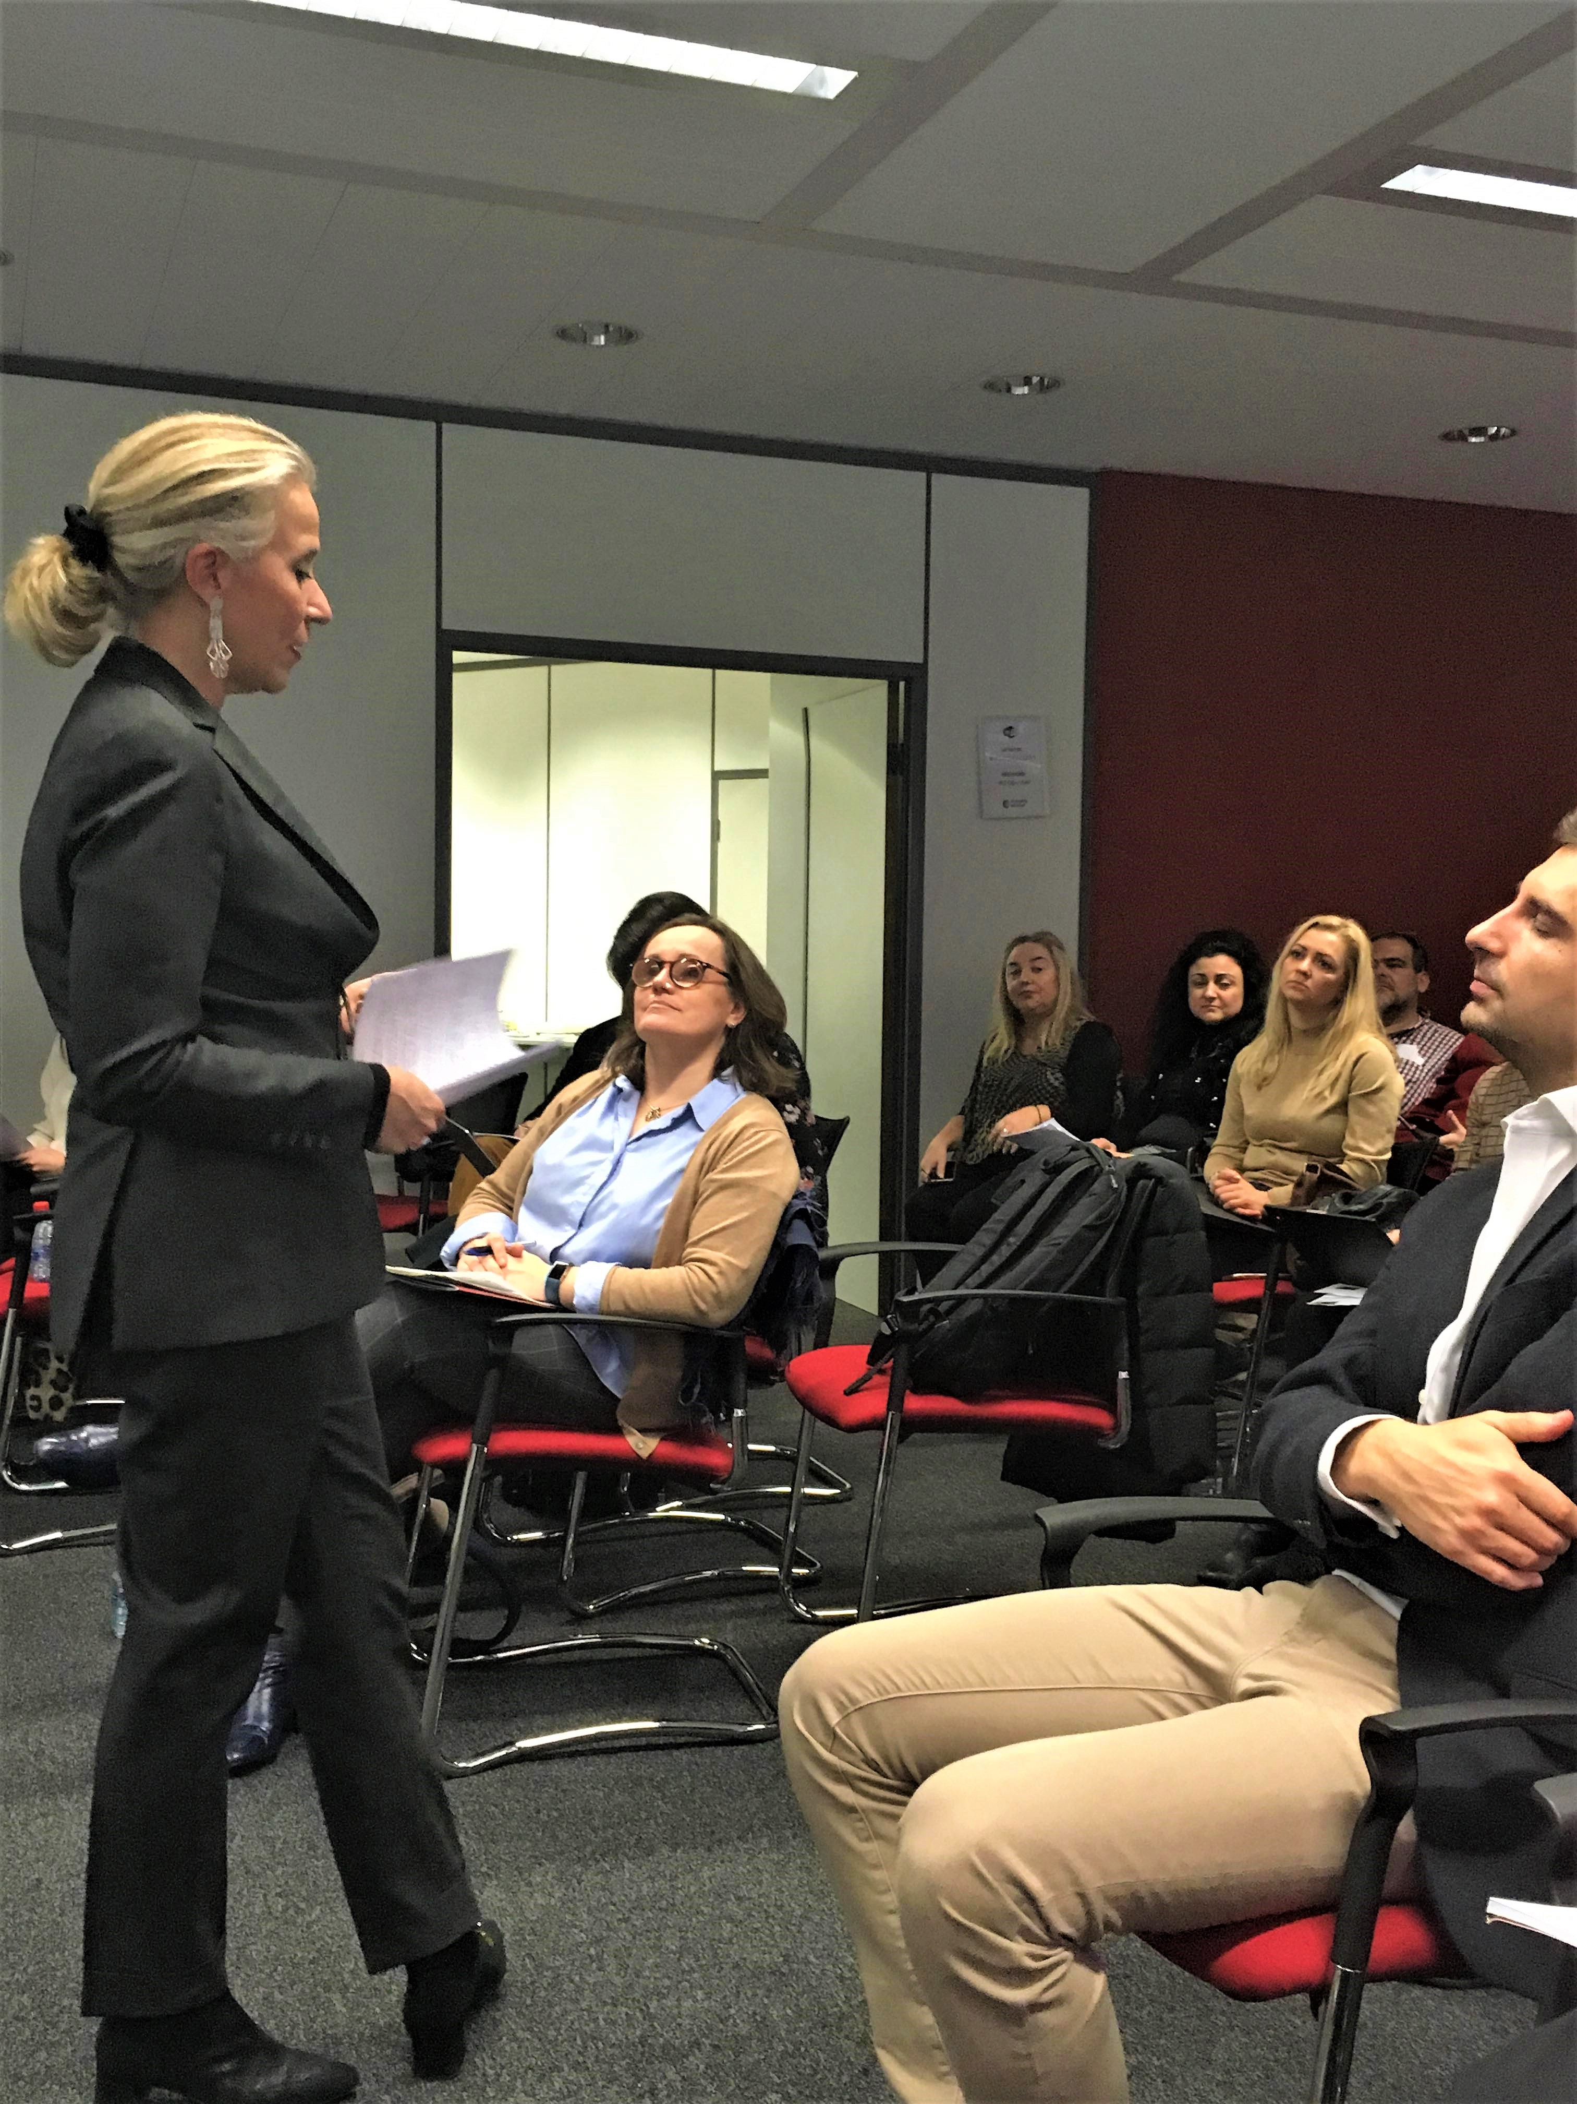
Lastly, Emmanuelle Grange, European Commission’s Head of Unit Disability and Inclusion, highlighted the European Commission’s perspective and its strategy for employment for people with disabilities. Broadly, several issues still act as an obstacle to employment for people with disabilities: awareness raising, reasonable accommodation and accessibility. This calls for more information sharing and training. In fact, according to the European Commission’s 2017 Public Consultation, employment was the focal issue raised by all stakeholders because of its links to broader themes of inclusion, independence and self-financing. Unfortunately, societal stigma still exists that portrays people with disabilities as unable to work. This is certainly a myth and social enterprises are a great method to combat this stigma. However, social enterprises were not very central to the European Commission’s Disability Strategy. As such, more needs to be done and investment in social enterprises is vital. Drafting the next Disability Strategy has begun. The official Strategy consultation process is to launch in Spring 2019 and all are encouraged to participate. Social economy has a strong potential for innovation and this should be made visible in the consultation process.

The Public Affairs Event concluded with a few words from Laura Jones, EPR Secretary General, and Sabrina Ferraina, EASPD Policy Manager. Social enterprises cannot be seen in isolation of the context they operate in and the perspectives of all stakeholders – particularly people with disabilities themselves. Finally, social enterprises are a significant tool that promote employment inclusion. Such a tool should be invested in.

